1.Create a new process by invoking the appropriate system call. Get the process identifier of the currently running process and its respective parent using system calls and display the same using a C program.
ANS:
CODE:
#include <stdio.h>
#include <unistd.h>

int main()
{
pid_t pid;

pid = fork();

if (pid < 0)
{
printf("Process creation failed\n");
}
else if (pid == 0)
{
printf("Child Process\n");
printf("Process ID: %d\n", getpid());
printf("Parent Process ID: %d\n", getppid());
}
else
{
printf("Parent Process\n");
printf("Process ID: %d\n", getpid());
printf("Parent Process ID: %d\n", getppid());
}

return 0;
}
OUTPUT:
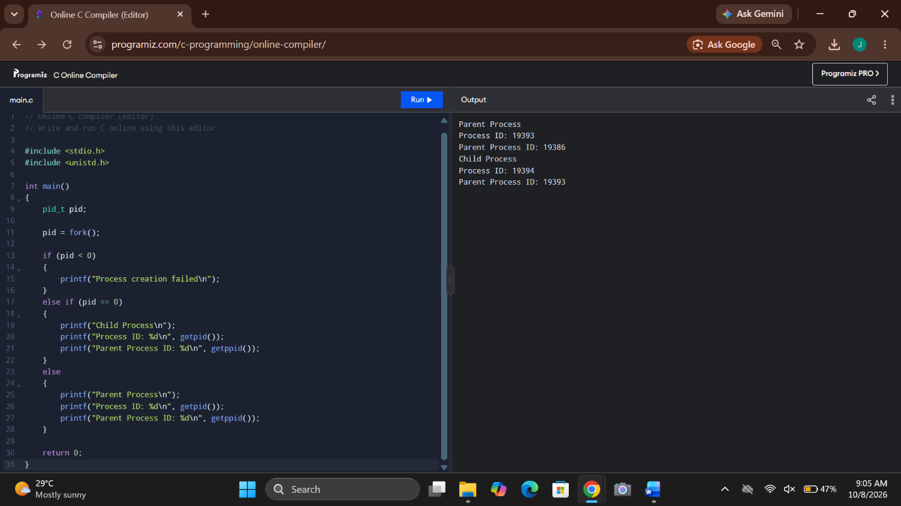
2. Identify the system calls to copy the content of one file to another and illustrate the same using a C program.
ANS: #include <stdio.h>
#include <fcntl.h>
#include <unistd.h>

int main()
{
int fd1, fd2, n;
char buffer[100];

fd1 = open("source.txt", O_RDONLY);

if (fd1 < 0) {
printf("Unable to open source file\n");
return 1;
}

fd2 = open("destination.txt",
O_WRONLY | O_CREAT | O_TRUNC, 0644);

if (fd2 < 0) {
printf("Unable to open destination file\n");
close(fd1);
return 1;
}

while ((n = read(fd1, buffer, sizeof(buffer))) > 0) {
write(fd2, buffer, n);
}

close(fd1);
close(fd2);

printf("File copied successfully\n");

return 0;
}

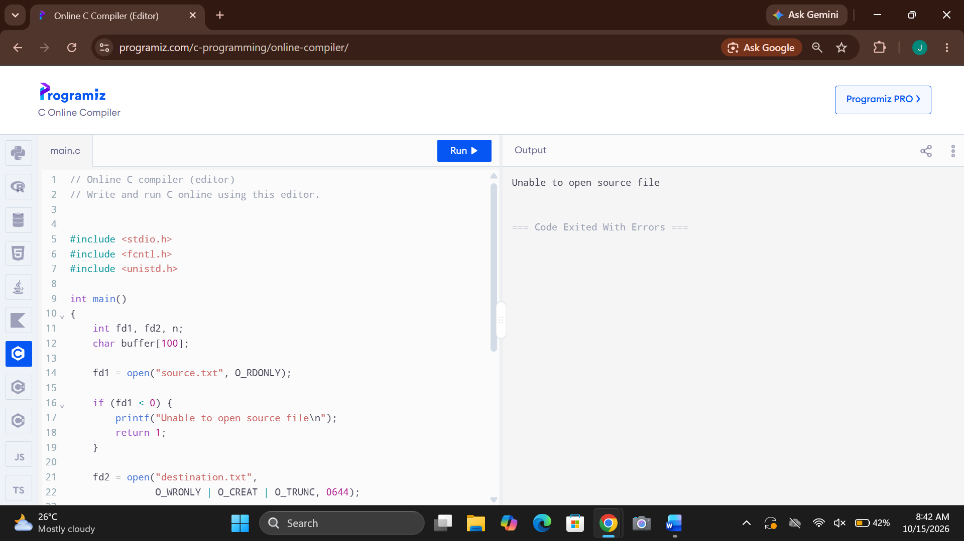
3. Design a CPU scheduling program with C using First Come First Served
technique with the following considerations.
a. All processes are activated at time 0.
b. Assume that no process waits on I/O devices
ANS: #include <stdio.h>

int main()
{
int n, i;
int bt[20], wt[20], tat[20];
float avgwt = 0, avgtat = 0;

printf("Enter number of processes: ");
scanf("%d", &n);

for (i = 0; i < n; i++)
{
printf("Enter burst time of P%d: ", i + 1);
scanf("%d", &bt[i]);
}

wt[0] = 0;

for (i = 1; i < n; i++)
wt[i] = wt[i - 1] + bt[i - 1];

for (i = 0; i < n; i++)
{
tat[i] = wt[i] + bt[i];
avgwt += wt[i];
avgtat += tat[i];
}

printf("\nProcess\tBT\tWT\tTAT\n");

for (i = 0; i < n; i++)
printf("P%d\t%d\t%d\t%d\n",
i + 1, bt[i], wt[i], tat[i]);

printf("\nAverage Waiting Time = %.2f",
avgwt / n);
printf("\nAverage Turnaround Time = %.2f\n",
avgtat / n);

return 0;
}

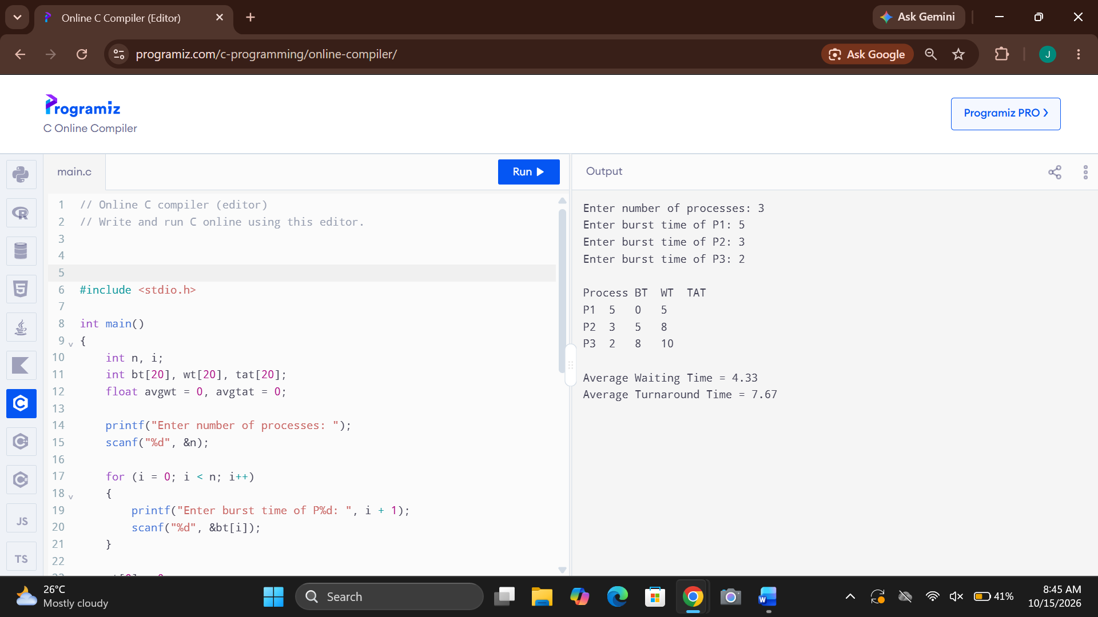
4. Construct a scheduling program with C that selects the waiting process with the
smallest execution time to execute next
ANS: #include <stdio.h>

int main()
{
int n, i, j, temp;
int bt[20], p[20], wt[20], tat[20];
float avgwt = 0, avgtat = 0;

printf("Enter number of processes: ");
scanf("%d", &n);

for (i = 0; i < n; i++)
{
printf("Enter burst time of P%d: ", i + 1);
scanf("%d", &bt[i]);
p[i] = i + 1;
}

// Sort processes by burst time
for (i = 0; i < n - 1; i++)
{
for (j = i + 1; j < n; j++)
{
if (bt[i] > bt[j])
{
temp = bt[i];
bt[i] = bt[j];
bt[j] = temp;

temp = p[i];
p[i] = p[j];
p[j] = temp;
}
}
}

wt[0] = 0;

for (i = 1; i < n; i++)
wt[i] = wt[i - 1] + bt[i - 1];

for (i = 0; i < n; i++)
{
tat[i] = wt[i] + bt[i];
avgwt += wt[i];
avgtat += tat[i];
}

printf("\nProcess\tBT\tWT\tTAT\n");

for (i = 0; i < n; i++)
printf("P%d\t%d\t%d\t%d\n",
p[i], bt[i], wt[i], tat[i]);

printf("\nAverage Waiting Time = %.2f", avgwt / n);
printf("\nAverage Turnaround Time = %.2f\n", avgtat / n);

return 0;
}

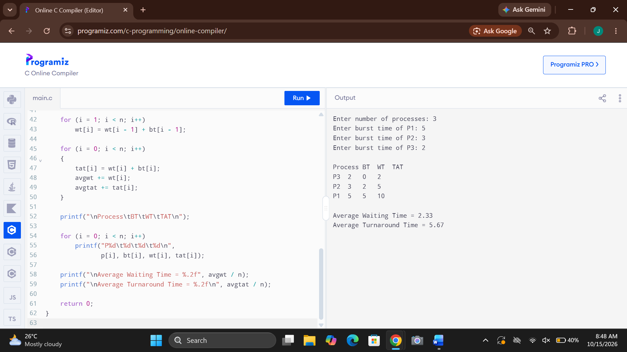
5. Construct a scheduling program with C that selects the waiting process with the
highest priority to execute next.
ANS: #include <stdio.h>

int main()
{
int n, i, j, temp;
int p[20], bt[20], pr[20], wt[20], tat[20];
float avgwt = 0, avgtat = 0;

printf("Enter number of processes: ");
scanf("%d", &n);

for (i = 0; i < n; i++)
{
p[i] = i + 1;
printf("Enter burst time and priority of P%d: ", i + 1);
scanf("%d%d", &bt[i], &pr[i]);
}

// Sort by priority (smaller number = higher priority)
for (i = 0; i < n - 1; i++)
{
for (j = i + 1; j < n; j++)
{
if (pr[i] > pr[j])
{
temp = pr[i];
pr[i] = pr[j];
pr[j] = temp;

temp = bt[i];
bt[i] = bt[j];
bt[j] = temp;

temp = p[i];
p[i] = p[j];
p[j] = temp;
}
}
}

wt[0] = 0;

for (i = 1; i < n; i++)
wt[i] = wt[i - 1] + bt[i - 1];

for (i = 0; i < n; i++)
{
tat[i] = wt[i] + bt[i];
avgwt += wt[i];
avgtat += tat[i];
}

printf("\nProcess\tBT\tPriority\tWT\tTAT\n");

for (i = 0; i < n; i++)
printf("P%d\t%d\t%d\t\t%d\t%d\n",
p[i], bt[i], pr[i], wt[i], tat[i]);

printf("\nAverage Waiting Time = %.2f", avgwt / n);
printf("\nAverage Turnaround Time = %.2f\n", avgtat / n);

return 0;
}

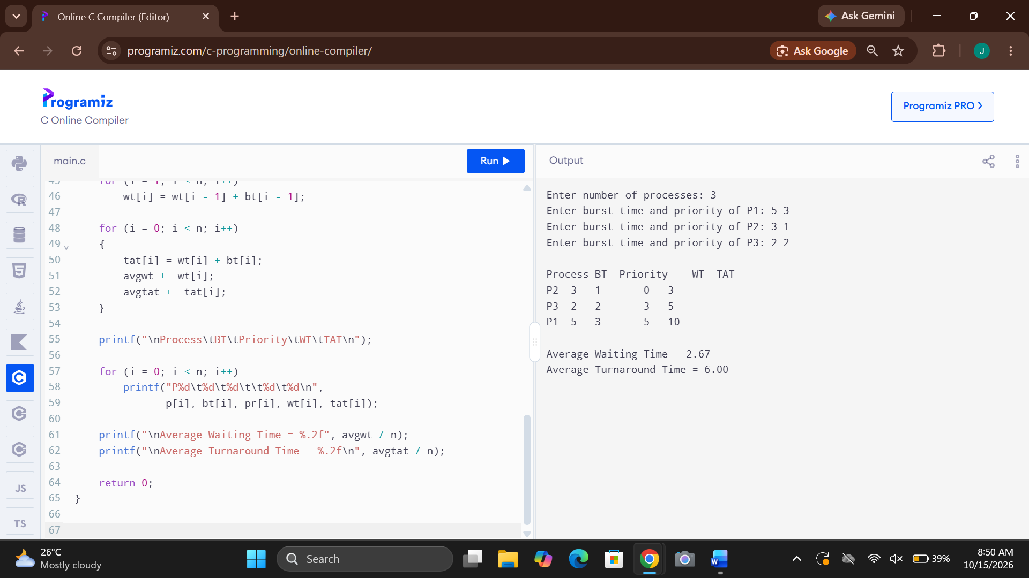
6. Construct a C program to implement preemptive priority scheduling algorithm
ANS: #include <stdio.h>

int main()
{
int n, i, time = 0, completed = 0;
int at[20], bt[20], rt[20], pr[20];
int wt[20] = {0}, tat[20] = {0};
int ct[20] = {0}, done[20] = {0};
float avgwt = 0, avgtat = 0;
int idx, minp;

printf("Enter number of processes: ");
scanf("%d", &n);

for (i = 0; i < n; i++)
{
printf("Enter arrival time, burst time and priority of P%d: ",
i + 1);
scanf("%d%d%d", &at[i], &bt[i], &pr[i]);
rt[i] = bt[i];
}

while (completed < n)
{
idx = -1;
minp = 9999;

for (i = 0; i < n; i++)
{
if (at[i] <= time && rt[i] > 0 &&
pr[i] < minp)
{
minp = pr[i];
idx = i;
}
}

if (idx == -1)
{
time++;
continue;
}

rt[idx]--;
time++;

if (rt[idx] == 0)
{
completed++;
ct[idx] = time;
tat[idx] = ct[idx] - at[idx];
wt[idx] = tat[idx] - bt[idx];
}
}

printf("\nProcess\tAT\tBT\tPriority\tWT\tTAT\n");

for (i = 0; i < n; i++)
{
printf("P%d\t%d\t%d\t%d\t\t%d\t%d\n",
i + 1, at[i], bt[i], pr[i],
wt[i], tat[i]);

avgwt += wt[i];
avgtat += tat[i];
}

printf("\nAverage Waiting Time = %.2f", avgwt / n);
printf("\nAverage Turnaround Time = %.2f\n",
avgtat / n);

return 0;
}

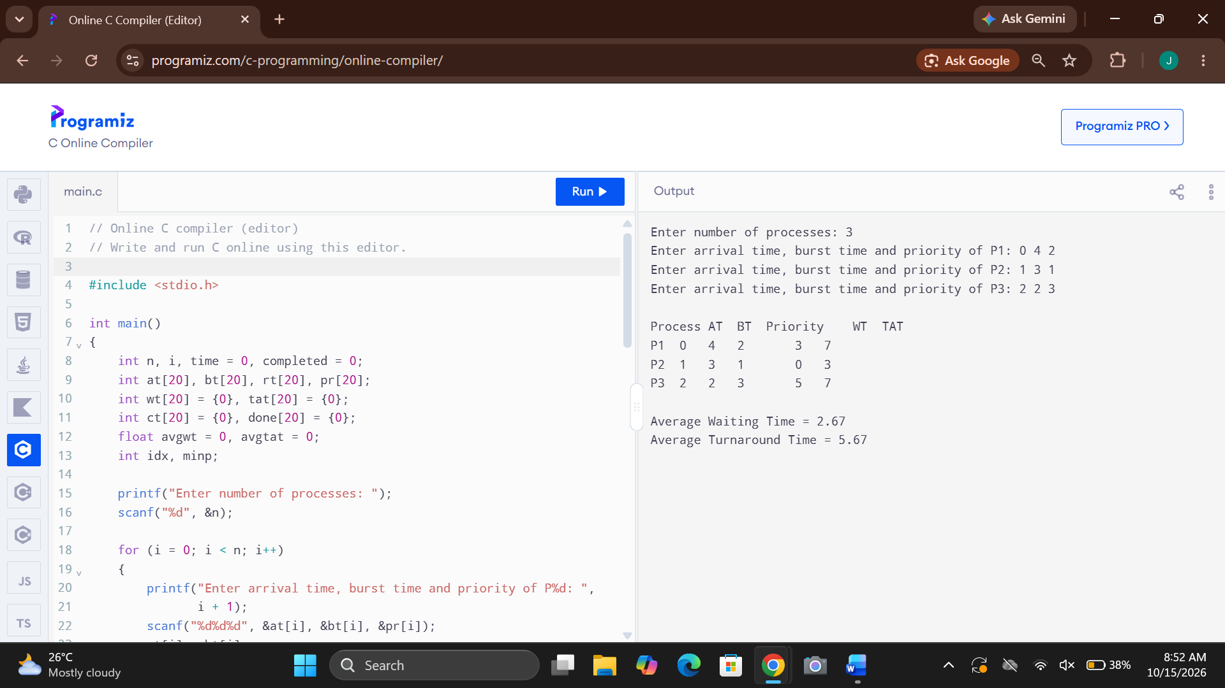
7. Construct a C program to implement a non-preemptive SJF algorithm.
ANS:
#include <stdio.h>

int main()
{
int n, i, j, temp, time = 0;
int bt[20], p[20], wt[20], tat[20];
float avgwt = 0, avgtat = 0;

printf("Enter number of processes: ");
scanf("%d", &n);

for (i = 0; i < n; i++)
{
p[i] = i + 1;
printf("Enter burst time of P%d: ", i + 1);
scanf("%d", &bt[i]);
}

// Sort by burst time
for (i = 0; i < n - 1; i++)
{
for (j = i + 1; j < n; j++)
{
if (bt[i] > bt[j])
{
temp = bt[i];
bt[i] = bt[j];
bt[j] = temp;

temp = p[i];
p[i] = p[j];
p[j] = temp;
}
}
}

for (i = 0; i < n; i++)
{
wt[i] = time;
tat[i] = wt[i] + bt[i];
time += bt[i];

avgwt += wt[i];
avgtat += tat[i];
}

printf("\nProcess\tBT\tWT\tTAT\n");

for (i = 0; i < n; i++)
printf("P%d\t%d\t%d\t%d\n",
p[i], bt[i], wt[i], tat[i]);

printf("\nAverage Waiting Time = %.2f",
avgwt / n);
printf("\nAverage Turnaround Time = %.2f\n",
avgtat / n);

return 0;
}

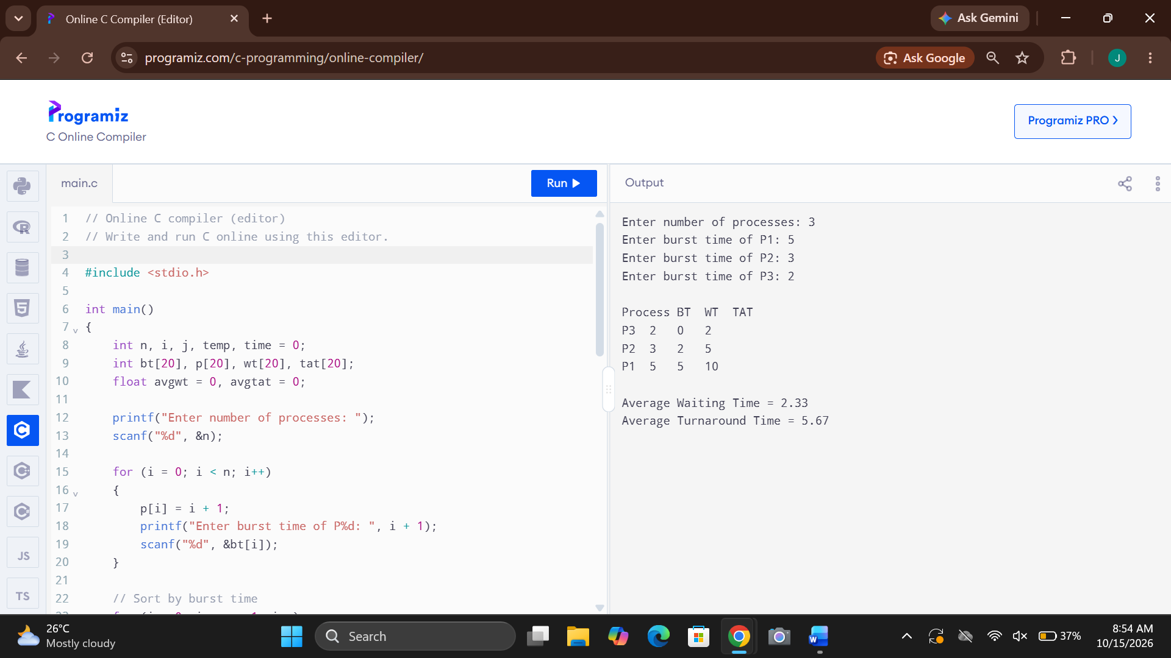
8. Construct a C program to simulate Round Robin scheduling algorithm with C.
ANS: #include <stdio.h>

int main()
{
int n, tq, i, time = 0, remain;
int bt[20], rt[20], wt[20], tat[20];
float avgwt = 0, avgtat = 0;

printf("Enter number of processes: ");
scanf("%d", &n);

for (i = 0; i < n; i++)
{
printf("Enter burst time of P%d: ", i + 1);
scanf("%d", &bt[i]);
rt[i] = bt[i];
}

printf("Enter time quantum: ");
scanf("%d", &tq);

remain = n;

while (remain > 0)
{
for (i = 0; i < n; i++)
{
if (rt[i] > 0)
{
if (rt[i] > tq)
{
time += tq;
rt[i] -= tq;
}
else
{
time += rt[i];
wt[i] = time - bt[i];
rt[i] = 0;
tat[i] = time;
remain--;
}
}
}
}

printf("\nProcess\tBT\tWT\tTAT\n");

for (i = 0; i < n; i++)
{
printf("P%d\t%d\t%d\t%d\n",
i + 1, bt[i], wt[i], tat[i]);

avgwt += wt[i];
avgtat += tat[i];
}

printf("\nAverage Waiting Time = %.2f",
avgwt / n);
printf("\nAverage Turnaround Time = %.2f\n",
avgtat / n);

return 0;
}
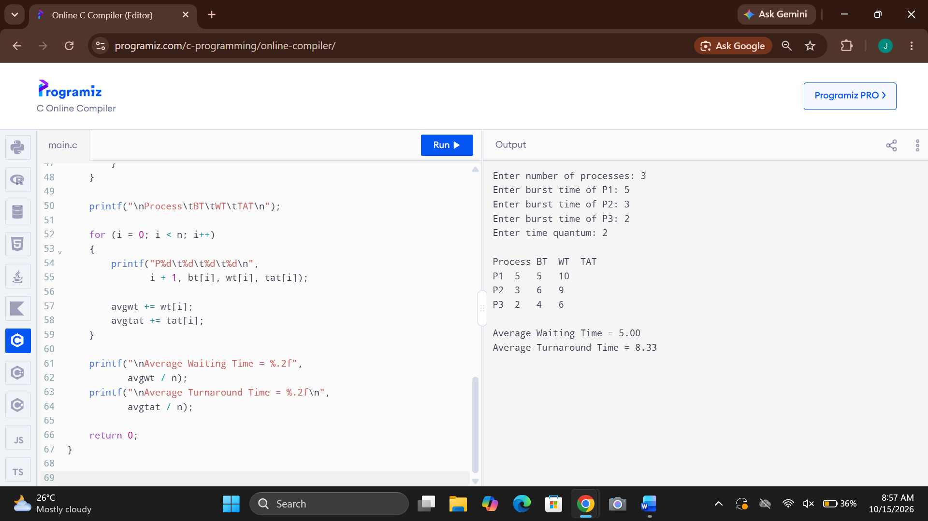
9. Illustrate the concept of inter-process communication using shared memory with
a C program.
ANS: #include <stdio.h>
#include <stdlib.h>
#include <unistd.h>
#include <sys/ipc.h>
#include <sys/shm.h>
#include <sys/wait.h>

int main()
{
int shmid;
int *shared;

shmid = shmget(IPC_PRIVATE, sizeof(int),
IPC_CREAT | 0666);

if (shmid < 0)
{
perror("shmget");
return 1;
}

shared = (int *)shmat(shmid, NULL, 0);

if (shared == (void *)-1)
{
perror("shmat");
shmctl(shmid, IPC_RMID, NULL);
return 1;
}

*shared = 0;

if (fork() == 0)
{
*shared = 100;
printf("Child writes: %d\n", *shared);
shmdt(shared);
exit(0);
}
else
{
wait(NULL);
printf("Parent reads: %d\n", *shared);

shmdt(shared);
shmctl(shmid, IPC_RMID, NULL);
}

return 0;
}

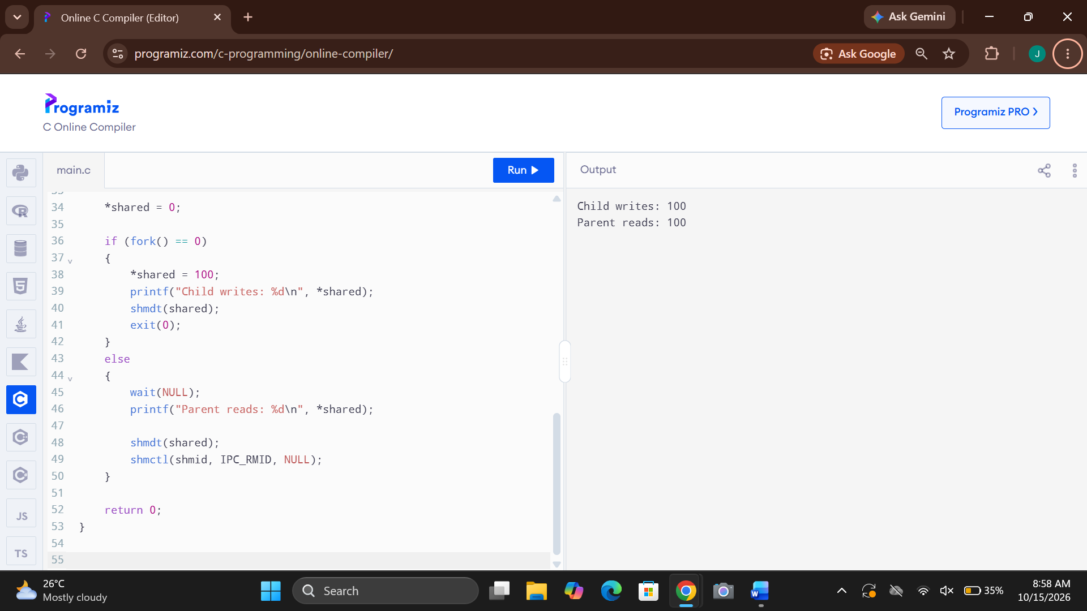
10. Illustrate the concept of inter-process communication using message queue with
a C program.
ANS: #include <stdio.h>
#include <stdlib.h>
#include <string.h>
#include <unistd.h>
#include <sys/ipc.h>
#include <sys/msg.h>
#include <sys/wait.h>

struct message {
long type;
char text[100];
};

int main()
{
int qid;
struct message msg;

qid = msgget(IPC_PRIVATE, IPC_CREAT | 0666);

if (qid == -1) {
perror("msgget");
return 1;
}

if (fork() == 0) {
msg.type = 1;
strcpy(msg.text, "Hello from child process");

if (msgsnd(qid, &msg, sizeof(msg.text), 0) == -1) {
perror("msgsnd");
exit(1);
}

exit(0);
}
else {
wait(NULL);

if (msgrcv(qid, &msg, sizeof(msg.text),
1, 0) == -1) {
perror("msgrcv");
msgctl(qid, IPC_RMID, NULL);
return 1;
}

printf("Parent received: %s\n", msg.text);
msgctl(qid, IPC_RMID, NULL);
}

return 0;
}

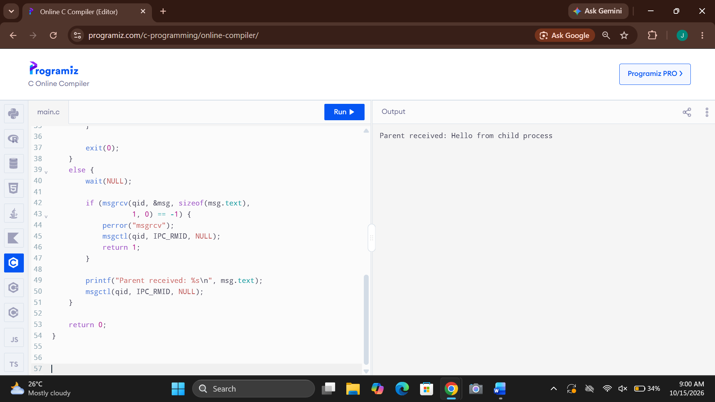
11. Illustrate the concept of multithreading using a C program.
ANS: #include <stdio.h>
#include <pthread.h>

void *display(void *arg)
{
printf("Thread is running\n");
return NULL;
}

int main()
{
pthread_t t1, t2;

pthread_create(&t1, NULL, display, NULL);
pthread_create(&t2, NULL, display, NULL);

pthread_join(t1, NULL);
pthread_join(t2, NULL);

printf("Main thread completed\n");

return 0;
}

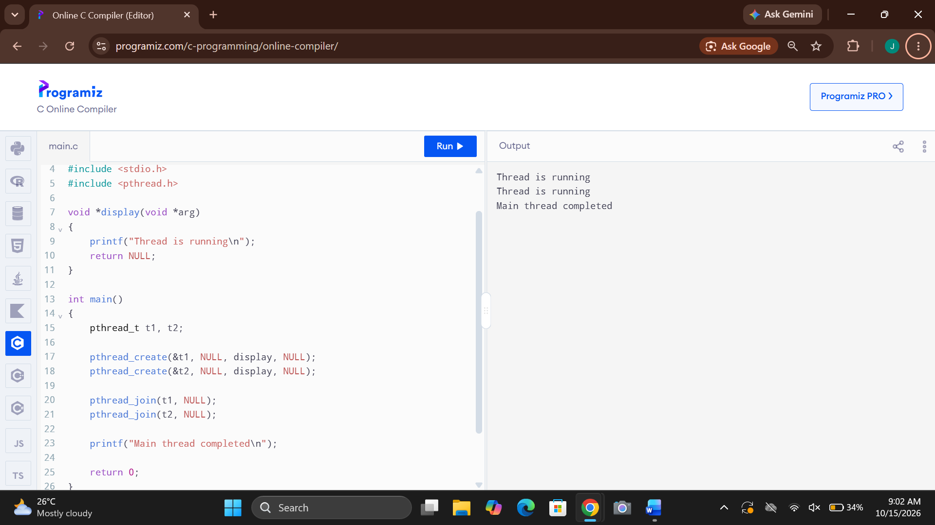
12. Design a C program to simulate the concept of Dining-Philosophers problem
ANS: #include <stdio.h>
#include <pthread.h>
#include <semaphore.h>
#include <unistd.h>

#define N 5

sem_t forks[N];
sem_t room;

void *philosopher(void *arg)
{
int id = *(int *)arg;

printf("Philosopher %d is thinking\n", id);

sem_wait(&room);
sem_wait(&forks[id]);
sem_wait(&forks[(id + 1) % N]);

printf("Philosopher %d is eating\n", id);
sleep(1);

sem_post(&forks[(id + 1) % N]);
sem_post(&forks[id]);
sem_post(&room);

printf("Philosopher %d finished eating\n", id);

return NULL;
}

int main()
{
pthread_t threads[N];
int id[N], i;

sem_init(&room, 0, N - 1);

for (i = 0; i < N; i++)
sem_init(&forks[i], 0, 1);

for (i = 0; i < N; i++)
{
id[i] = i;
pthread_create(&threads[i], NULL,
philosopher, &id[i]);
}

for (i = 0; i < N; i++)
pthread_join(threads[i], NULL);

for (i = 0; i < N; i++)
sem_destroy(&forks[i]);

sem_destroy(&room);

return 0;
}

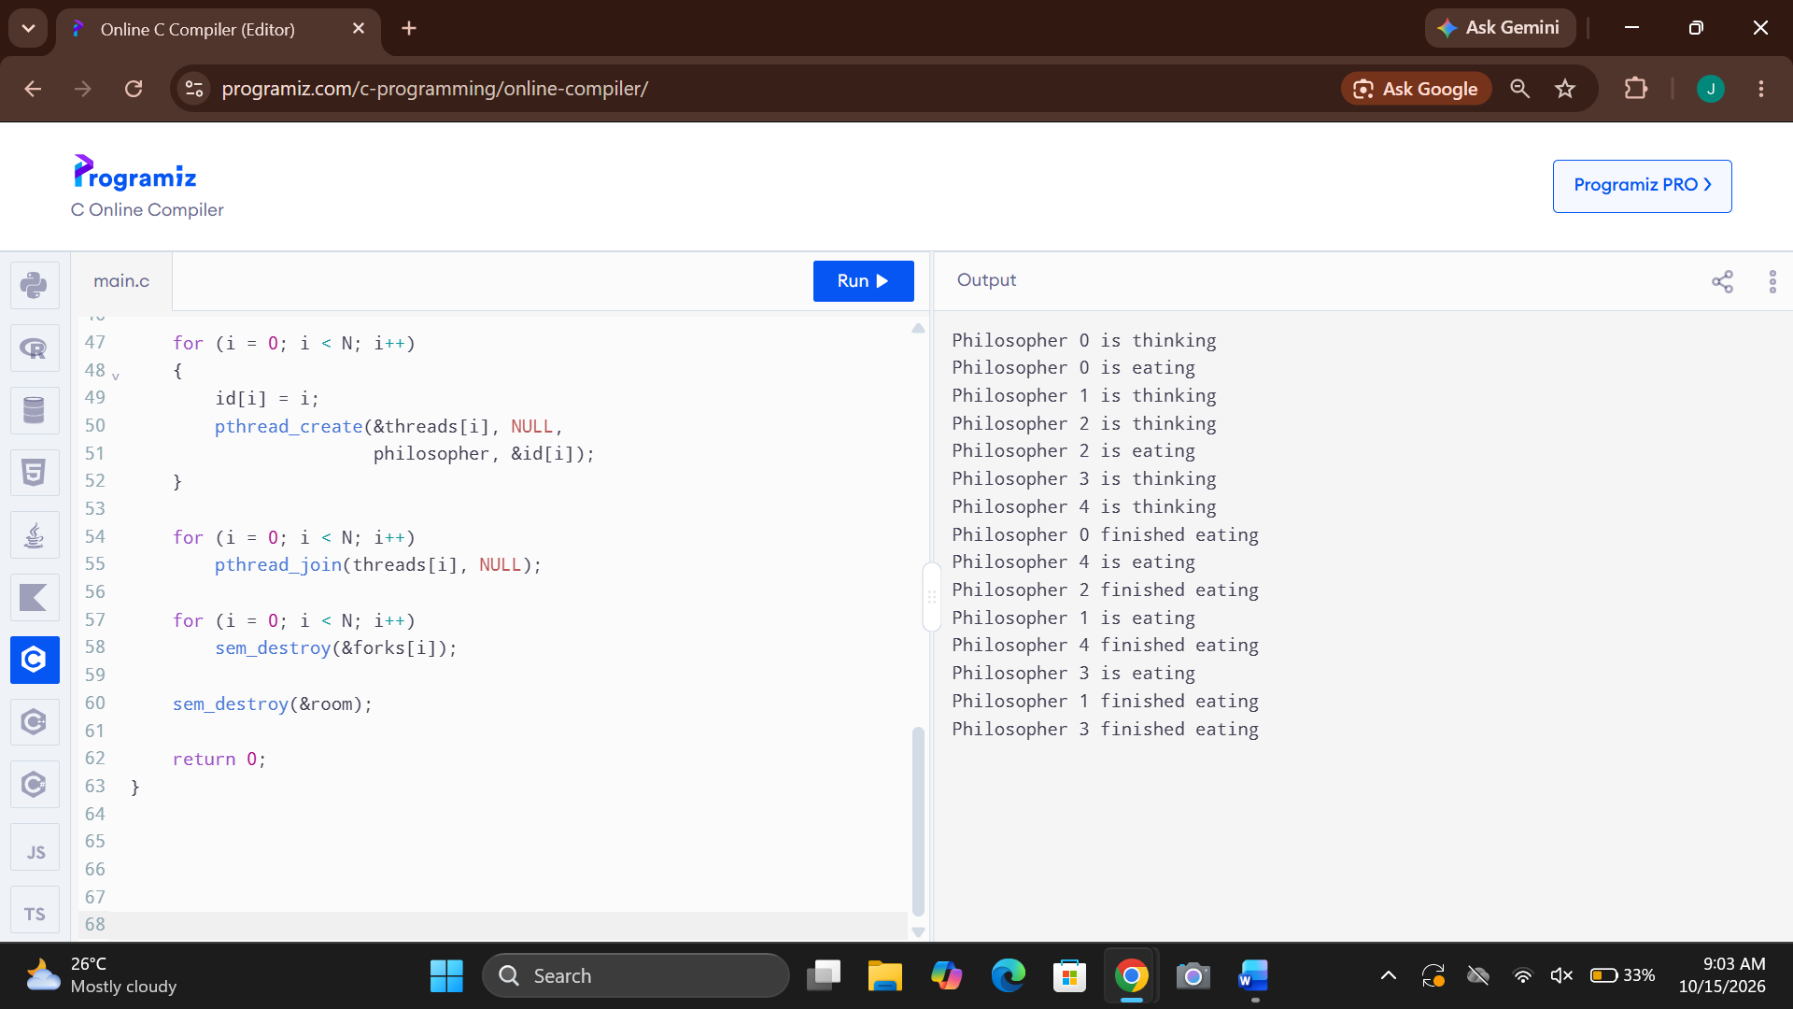
13. Construct a C program to implement various memory allocationstrategies.
ANS:
#include <stdio.h>
int main()
{
int b[20], p[20], alloc[20];
int nb, np, i, j, choice, best;
printf("Enter number of memory blocks: ");
scanf("%d", &nb);
printf("Enter size of each block:\n");
for (i = 0; i < nb; i++)
scanf("%d", &b[i]);
printf("Enter number of processes: ");
scanf("%d", &np);
printf("Enter size of each process:\n");
for (i = 0; i < np; i++)
scanf("%d", &p[i]);
printf("1.First Fit 2.Best Fit 3.Worst Fit\n");
printf("Enter choice: ");
scanf("%d", &choice);
for (i = 0; i < np; i++)
alloc[i] = -1;
for (i = 0; i < np; i++)
{
best = -1;
for (j = 0; j < nb; j++)
{
if (b[j] >= p[i])
{
if (choice == 1)
{
best = j;
break;
}
else if (choice == 2)
{
if (best == -1 || b[j] < b[best])
best = j;
}
else if (choice == 3)
{
if (best == -1 || b[j] > b[best])
best = j;
}
}
}
if (best != -1)
{
alloc[i] = best;
b[best] -= p[i];
}
}
printf("\nProcess\tSize\tBlock\n");
for (i = 0; i < np; i++)
{
printf("%d\t%d\t", i + 1, p[i]);
if (alloc[i] != -1)
printf("%d\n", alloc[i] + 1);
else
printf("Not Allocated\n");
}
return 0;
}
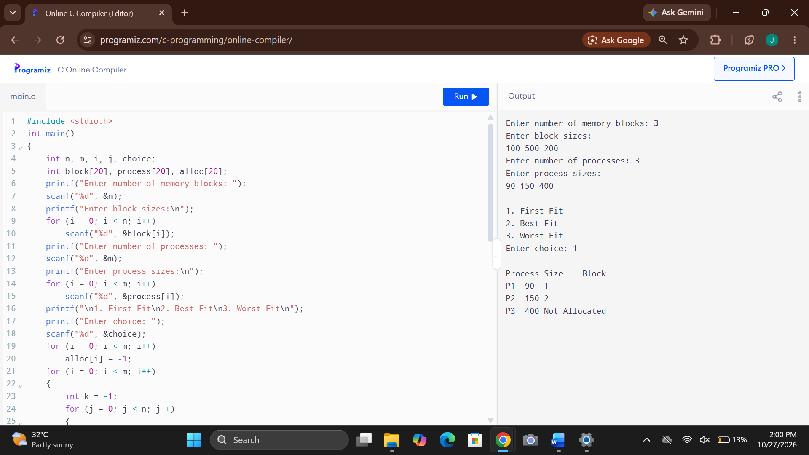
14.Construct a C program to organize the file using single leveldirectory.
ANS:

